

***CYLINDRICAL STRUCTURE JUNCTIONLESS MOSFET***

COMPARISON BASED ON CHANNEL ENGINEERING



***SUBMITTED TO: - MRS. PAWANDEEP KAUR***

***SUBMITTED BY: - SANCHIT AGGARWAL***

***REG.NO: - 11902988***

***SECTION: - K19Pg***

***ROLL NO.: - K19PGA06***

**ABSTRACT**

Junctionless transistors are variable resistors constrained by a door cathode. The silicon channel is an intensely doped nanowire that can be completely drained to kill the gadget. The electrical qualities are indistinguishable from those of typical MOSFETs, yet the material science is very extraordinary. This paper looks at the conduction components in three kinds of MOS gadgets: reversal mode, gathering mode and junctionless MOSFET.

**INTRODUCTION\**

The metal–oxide–semiconductor field-impact transistor (MOSFET) otherwise called the metal–oxide–silicon transistor (MOS) is a sort of field-impact transistor that is made by the oxidation of a semiconductor, for the most part silicon. It has a secured door and whose voltage decides the conductivity of the gadget. This capacity to change the conductivity with the applied voltage that can be utilized for intensifying or exchanging.

MOSFET are utilized for some applications, for example, enhancers, sound hardware, auto thought processes, biosensors, cameras, mini-computers, PCs, shopper gadgets, home diversion, modern gear, the Internet, LED lighting, cell phones, control hardware, control supplies, 3D printers, satellites, shuttle, media transmission, TV, computer games, watches, remote systems, and X-beam, among different employments. The USPTO considers it a "historic" development that changed and Enhanced the personal satisfaction and culture the world over".

The MOSFET is the most widely recognized semiconductor gadget in computerized and simple circuits. It was the primary really smaller transistor that could be scaled down and mass-delivered for a wide scope of employments, altering the gadgets business and the world economy, having been integral to the PC unrest, computerized unrest, data upheaval, silicon age and data age.

**BACKGROUND**

Egyptian engineer Mohamed M. Atalla in late 1950’s, adopted a new method of semiconductor device fabrication, coating a silicon metal part with an layer of silicon oxide which is insulating in nature, so that electricity could easily go inside to the conducting silicon below, overcoming the surface states that prevented electricity from reaching the semiconducting layer. This is known as surface passivation, a method that later became critical to the semiconductor industry as it made possible the mass-production of silicon semiconductor technology, such as integrated circuit (IC) chips. For the surface passivation process, he developed the method of thermal oxidation, which was a breakthrough in silicon semiconductor technology. Building on the surface passivation method, Atalla developed the metal–oxide–semiconductor (MOS) process, with the use of thermally oxidized silicon. He proposed that the MOS process could be used to build the first working silicon FET, which he began working on building with the help of Korean recruit Dawon Kahng.

The MOSFET was invented by Mohamed Atalla and Dawon Kahng in 1959.They fabricated the device in November 1959, and presented it as the "silicon–silicon dioxide field induced surface device" in early 1960. The device is covered by two patents, each filed separately by Atalla and Kahng in March 1960.Operationally and structurally different from the bipolar junction transistor(BJT), the MOSFET was made by putting an insulating layer on the surface of the semiconductor and then placing a metallic gate electrode on that. It used crystalline silicon for the semiconductor and a thermally oxidized layer of silicon dioxide for the insulator. The silicon MOSFET did not generate localized electron traps at the interface between the silicon and its native oxide layer, and thus was inherently free from the trapping and scattering of carriers that had impeded the performance of earlier attempts at building a field-effect transistor.

**MOSFET Working Principle**

The working of MOSFET relies on the metal oxide capacitor (MOS) that is the fundamental piece of the MOSFET. The oxide layer presents among the source and channel terminal. It tends to be set from p-type to n-type by applying positive or negative voltages at the entryway individually. At the point when apply the positive entryway voltage the openings present under the oxide layers are driven descending through the substrate because of the loathsome power.

**TYPES**

There are two types of MOSFET: -

* **Enhancement Type**
  + In an enhancement mode MOSFET, voltage applied to the gate terminal can increase the conductivity from the "normally off" state.
* **Depletion type** 
  + In a depletion mode MOSFET, voltage applied at the gate can reduce the conductivity from the "normally on" state.

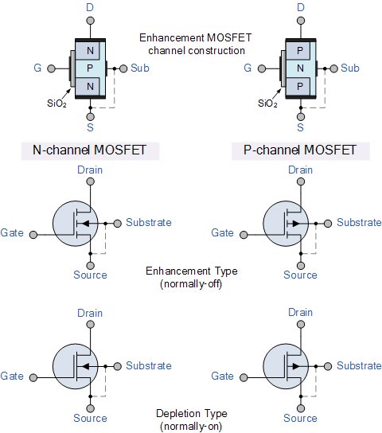

The four MOSFET symbols above show a terminal called the Substrate and is not normally used for any kind of input or output but on the other hand its is used for the grounding purpose in a MOSFET. It connects to the main semi conductive channel through a diode junction to the body or metal tab of the MOSFET.

Usually in MOSFETs, this substrate lead is connected internally to the source terminal. When this is the case, as in enhancement types it is omitted from the symbol for clarification.

The line in the MOSFET symbol between the drain (D) and source (S) connections represents the transistors semi conductive channel. If this channel line is a solid unbroken line, then it represents a “Depletion” (normally-ON) type MOSFET as drain current can flow with zero gate biasing potential which can be also said as Vgs=0.

If the channel line is shown as a dotted or broken line, then it represents an “Enhancement” (normally-OFF) type MOSFET as zero drain current flows with zero gate potential. The direction of the arrow pointing to this channel line indicates whether the conductive channel is a P-type or an N-type semiconductor device.

Both are further classified into two types each

**Basic MOSFET Structure and Symbol**

* **MOSFET CONSTRUCTION**

The development of the Metal Oxide Semiconductor FET is altogether different to that of the Junction FET. Both the Depletion and Enhancement type MOSFETs utilize an electrical field created by a door voltage to change the progression of charge bearers, electrons for n-channel or openings for P-channel, through the semi conductive channel source channel. The door terminal is put at the highest point of an exceptionally slight non directing/protecting layer and there are a couple of little n-type areas just beneath the channel and source anode.

The door of an intersection field impact transistor, JFET must be one-sided so as to invert inclination the pn intersection. With a protected door MOSFET gadget no such constraints apply so it is conceivable to predisposition the entryway of a MOSFET in either extremity, positive (+ve) or negative (- ve).

This makes the MOSFET gadget particularly significant as electronic switches or to make rationale doors in light of the fact that with no predisposition they are regularly non-leading and this high entryway input opposition implies that almost no or no control current is required as MOSFETs are voltage controlled gadgets. Both the p-channel and the n-direct MOSFETs are accessible in two fundamental structures, the Enhancement type and the Depletion type.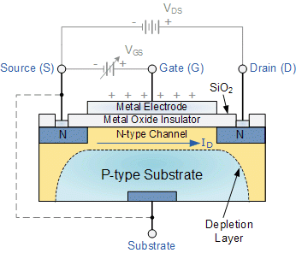

* **CYLINDRICAL STRUCTURE OF MOSFET**

GAA is by one way or another like FETs with the exception of the leading channel is encompassed by door all around. In this manner we show signs of improvement door controllability over the channel. The channel shape can be square or some other polygon shape.

Nanowire structure can be characterized as an article with 1D angle wherein the length to width proportion is more prominent than 10nm and width is under 10nm. The direct can be barrel shaped in structure and door is roundabout (360 degree) in nature. The breadth of channel can be kept underneath 10nm without influencing it's electrical properties.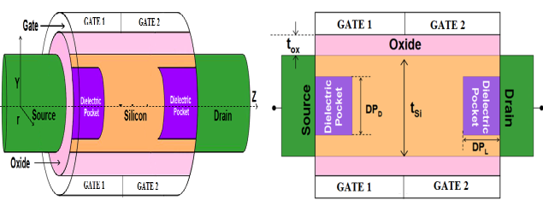

* **JUNCTIONLESS MOSFET**

MOSFET an intersection less transistor is without intersections and its present drive is constrained by the doping fixation rather than the entryway capacitance. Intersections are hard to manufacture, and, in light of the fact that they are a critical wellspring of current spillage, they squander noteworthy power and warmth. Killing them held the guarantee of less expensive and denser microchips. The JNT utilizes a basic nanowire of silicon encompassed by an electrically confined "wedding band" that demonstrations to entryway the progression of electrons through the wire. This strategy has been depicted as likened to pressing a nursery hose to door the progression of water through the hose. The nanowire is vigorously n-doped, making it a superb transmitter. Urgently the door, involving silicon, is intensely p-doped; and its essence exhausts the basic silicon nanowire along these lines forestalling transporter stream past the entryway.

**Depletion-mode MOSFET**

The Depletion-mode MOSFET, which is less common than the enhancement mode types is normally switched “ON” (conducting) without the application of a gate bias voltage. That is the channel conducts when VGS = 0 making it a “normally-closed” device. The circuit symbol shown above for a depletion MOS transistor uses a solid channel line to signify a normally closed conductive channel.

**N Channel Depletion**

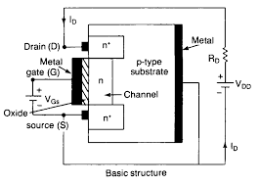

In N channel depletion VGS=0,i.e. it works as a closed switch, A positive voltage VDS is applied between the drain and the source terminal as a result of which all the eletron in the n region get attracted towards the positive side and where as holes get repelled. This helps in the formation of current (IDSS or ID) which is flowing between drain and source. This current can be increased by the usage more higher positive potential but after a particular voltage current will not increase further.

**P Channel Depletion**

In P Channel depletion type VGS is still zero and VDS is negative. As a result whole case is reversed and electron get repelled to p side where they recombine and holes are attracted to form a channel but at the time of current electron recombine with holes in p channel as result current reduces. As the VDS is increased negatively more will be decrease in the current and when at a point current is zero the state is called Pinch off state.

**Depletion-mode MOSFET and circuit Symbols**

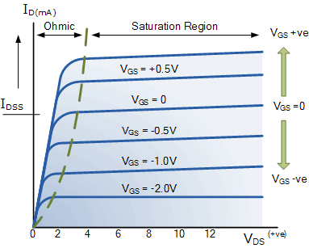

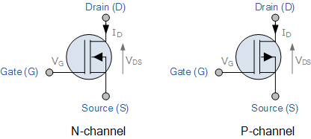

The depletion-mode MOSFET is constructed in a similar way to their JFET transistor counterparts were the drain-source channel is inherently conductive with the electrons and holes already present within the n-type or p-type channel. This doping of the channel produces a conducting path of low resistance between the Drain and Source with zero Gate bias.

**Enhancement-mode MOSFET**

The more typical Enhancement-mode MOSFET or eMOSFET, is the turn around of the consumption mode type. Here the leading channel is softly doped or even undoped making it non-conductive. This outcomes in the gadget being ordinarily "OFF" (non-directing) when the door inclination voltage, VGS is equivalent to zero. The circuit image appeared above for an upgrade MOS transistor utilizes a messed up channel line to imply a regularly open non leading channel.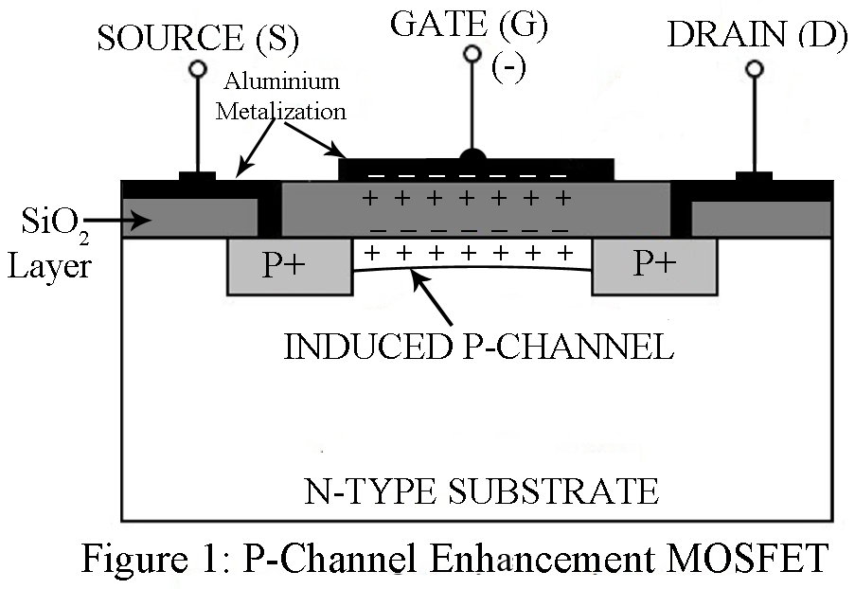

For the n-channel enhancement MOS transistor a drain current will only flow when a gate voltage ( VGS ) is applied to the gate terminal greater than the threshold voltage ( VTH ) level in which conductance takes place making it a transconductance device i.e. for condition VGS >VTH current will flow otherwise not.

The application of a positive (+ve) gate voltage to a n-type Enhancement MOSFET attracts more electrons towards the oxide layer around the gate thereby increasing or enhancing (hence its name) the thickness of the channel allowing more current to flow. This is why this kind of transistor is called an enhancement mode device as the application of a gate voltage enhances the channel.

Increasing this positive gate voltage will cause the channel resistance to decrease further causing an increase in the drain current, ID through the channel. In other words, for an n-channel enhancement mode MOSFET: +VGS turns the transistor “ON”, while a zero or -VGS turns the transistor “OFF”. Thus the enhancement-mode MOSFET is equivalent to a “normally-open” switch. The voltage difference Between source and drain is given by VGS- VDS which is equal to VG -VD.

VGS- VDS=VG- VD

As the saturation point applied voltage is max and channel is narrow, which gives rise to pinch off condition. At that instant VDS=VGS-Vth.

The reverse is true for the p-channel enhancement MOS transistor. When VGS = 0 the device is “OFF” and the channel is open. The application of a negative (-ve) gate voltage to the p-type Enhancement MOSFET enhances the channels conductivity turning it “ON”. Then for an p-channel enhancement mode MOSFET: +VGS turns the transistor “OFF”, while -VGS turns the transistor “ON”.

**Enhancement-mode MOSFET and Circuit Symbols**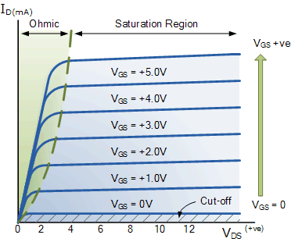

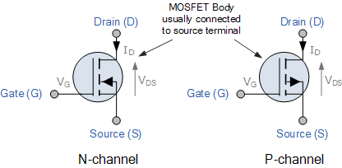

For operation is ohmic region the condition is VDS<VGS-VTH and VGS>VTH.

For saturation VDS≥ VGS-VTh  and for cutoff Vgs <Vth.

Enhancement-mode MOSFETs make excellent electronics switches due to their low “ON” resistance and extremely high “OFF” resistance as well as their infinitely high input resistance due to their isolated gate. Enhancement-mode MOSFETs are used in integrated circuits to produce CMOS type Logic Gates and power switching circuits in the form of as PMOS (P-channel) and NMOS (N-channel) gates. CMOS actually stands for Complementary MOS meaning that the logic device has both PMOS and NMOS within its design.

**COMPARISON BETWEEN TYPES OF MOSFETS i.e. DEPLETION AND ENHANCEMENT TYPE MOSFETS**

The Metal Oxide Semiconductor Field Effect Transistor, or MOSFET for short, has an extremely high input gate resistance with the current flowing through the channel between the source and drain being controlled by the gate voltage. Because of this high input impedance and gain, MOSFETs can be easily damaged by static electricity if not carefully protected or handled.

MOSFET’s are ideal for use as electronic switches or as common-source amplifiers as their power consumption is very small. Typical applications for metal oxide semiconductor field effect transistors are in Microprocessors, Memories, Calculators and Logic CMOS Gates etc.

Also, notice that a dotted or broken line within the symbol indicates a normally “OFF” enhancement type showing that “NO” current can flow through the channel when zero gate-source voltage VGS is applied.

A continuous unbroken line within the symbol indicates a normally “ON” Depletion type showing that current “CAN” flow through the channel with zero gate voltage. For p-channel types the symbols are exactly the same for both types except that the arrow points outwards. This can be summarised in the following switching table.

|  |  |  |  |
| --- | --- | --- | --- |
| MOSFET TYPE | VGS=+VE | VGS=0 | VGS=-VE |
| N-channel  Depletion | ON | ON | OFF |
| N- channel Enhancement | ON | OFF | OFF |
| P-channel  Depletion | OFF | ON | ON |
| P- channel Enhancement | OFF | OFF | ON |

So for n-type enhancement type MOSFETs, a positive gate voltage turns “ON” the transistor and with zero gate voltage, the transistor will be “OFF”. For a p-channel enhancement type MOSFET, a negative gate voltage will turn “ON” the transistor and with zero gate voltage, the transistor will be “OFF”. The voltage point at which the MOSFET starts to pass current through the channel is determined by the threshold voltage VTH of the device.

In the next tutorial about Field Effect Transistors instead of using the transistor as an amplifying device, we will look at the operation of the transistor in its saturation and cut-off regions when used as a solid-state switch. Field effect transistor switches are used in many applications to switch a DC current “ON” or “OFF” such as LED’s which require only a few milliamps at low DC voltages, or motors which require higher currents at higher voltages.

**SOME MAJOR APPLICATIONS OF MOSFETS DEVELOPED OVER THE YEARS:-**

**MOSFET Used as a Switch**

In this circuit, using enhanced mode, a N-channel MOSFET is being used to switch the lamp for ON and OFF. The positive voltage is applied at the gate of the MOSFET and the lamp is ON (VGS =+v) or at the zero voltage level the device turns off (VGS=0). If the resistive load of the lamp was to be replaced by an inductive load and connected to the relay or diode to protect the load, it is a very simple circuit for switching a resistive load such as LEDs or lamp. But when using MOSFET to switch either inductive load or capacitive load protection is required to contain the MOSFET applications. If we are not giving the protection, then the MOSFET will be damaged. For the MOSFET to operate as an analog switching device, that needs to be switched between its cutoff region where VGS =0 and saturation region where VGS =+v.

**Auto Intensity Control of Street Lights using MOSFET**

Now-a-days most of lights placed on the highways are done through High Intensity Discharge lamps (HID), whose energy consumption is high. Its intensity cannot be controlled according to the requirement, so there is a need to switch on to an alternative method of lighting system, i.e., to use LEDs. This system is built to overcome the present day drawbacks of HID lamps. This project is designed to control the lights automatically on the highways using microprocessor by variants of the clock pulses. In this project, MOSFET plays major role that is used to switch the lamps as per the requirement. Here we can replace the LEDs in place of HID lamps which are connected to the processor with the help of the MOSFET. The microcontroller release the respective duty cycles, then switch the MOSFET to illuminate the light with bright intensity

**Marx Generator Based High Voltage Using MOSFET**

The main concept of this project is to develop a circuit that delivers the output approximately triple to that of the input voltage by Marx generator principle. It is designed to generate high-voltage pulses using a number of capacitors in parallel to charge during the on time, and then connected in series to develop a higher voltage during the off period. If the input voltage applied is around 12v volts DC, then the output voltage is around 36 volts DC. This system utilizes a 555 timer in astable mode, which delivers the clock pulses to charge the parallel capacitors during on time and the capacitors are brought in a series during the off time through MOSFET switches; and thus, develops a voltage approximately triple to the input voltage but little less, instead of exact 36v due to the voltage drop in the circuit. The output voltage can be measured with the help of the multimeter.

**LDR Based Power Saver for Intensity Controlled Street Light**

In the present system, mostly the lightning-up of highways is done through High Intensity Discharge lamps (HID), whose energy consumption is high and there is no specialized mechanism to turn on the Highway light in the evening and switch off in the morning.

Its intensity cannot be controlled according to the requirement, so there is a need to switch to an alternative method of lighting system, i.e., by using LEDs. This system is built to overcome the present day, drawback of HID lamps.

This system demonstrates the usage of LEDs (light emitting diodes) as light source and its variable intensity control, according to the requirement. LEDs consume less power and its life is more, as compared to conventional HID lamps. The most important and interesting feature is its intensity that can be controlled according to requirement during non-peak hours, which is not feasible in HID lamps. A light sensing device LDR (Light Dependent Resistance) is used to sense the light. Its resistance reduces drastically according to the daylight, which forms as an input signal to the controller. A cluster of LEDs is used to form a street light. The microcontroller contains programmable instructions that controls the intensity of lights based on the PWM (Pulse width modulation) signals generated.

The intensity of light is kept high during the peak hours, and as the traffic on the roads tend to decrease in late nights; the intensity also decreases progressively till morning. Finally the lights get completely shut down at morning 6 am, to resume again at 6pm in the evening. The process thus repeats.

**References:-**

1. <https://www.youtube.com/watch?v=XqGBNyhImV4>
2. <https://en.wikipedia.org/>
3. https://www.elprocus.com/
4. www.researchgate.net